Game Playing
Games provided a structured task in which it was very easy to measure success or failure. Games did not obviously require large amounts of knowledge, thought to be solvable by straightforward search.Games are good vehicles for research because they are well formalized, small, and self-contained. They are therefore easily programmed. Games can be good models of competitive situations, so principles discovered in game-playing programs may be applicable to practical problems.
Game playing has been a major topic of AI since the very beginning. Beside the attraction of the topic to people, it is also because its close relation to "intelligence", and its well-defined states and rules. The most common used AI technique in game is search. In other problem-solving activities, state change is solely caused by the action of the agent. However, in Multi-agent games, it also depends on the actions of other agents who usually have different goals.
A special situation that has been studied most is "two-person zero-sum game", where the two players have exactly opposite goals. (Not all competition are zero-sum!). Given sufficient time and space, usually an optimum solution can be obtained for the former by exhaustive search, though not for the latter. However, for most interesting games, such a solution is usually too inefficient to be practically used.
Game playing is always popular with humans. Chess and Go are two popular games. Claude Shannon and Alan Turing introduced the first chess programs in 1950. Chess was chosen due to its simplicity, concrete representations, and popularity. Chess programs were viewed as existence proof of a machine doing something thought to require intelligence.
Having an opponent at the game introduces uncertainty. In all game programs, one should deal with the contingency problem. It refers to the fact that every branch of the search tree deals with a possible contingency that may arise. Games are often too hard to solve. Uncertainty arises since there is no enough time to calculate the exact consequences of any move. Games have heavy penalties for inefficiency. Pruning helps us remove parts of the search tree that make no difference to the game while heuristic evaluation functions get us close to a true utility of a state without having to complete a full search.

Representation of games
The games studied by game theory are well-defined mathematical objects. A game consists of a set of players, a set of moves (or strategies) available to those players, and a specification of payoffs for each combination of strategies. There are two ways of representing games that are common in the literature.

1. Normal form
The normal (or strategic form) game is usually represented by a matrix which shows the players, strategies, and payoffs (see the example below). More generally it can be represented by any function that associates a payoff for each player with every possible combination of actions. In the accompanying example there are two players; one chooses the row and the other chooses the column.

 | Player 2  chooses Left | Player 2  chooses Right
Player 1  chooses Up | 4, 3 | –1, –1
Player 1  chooses Down | 0, 0 | 3, 4
Normal form or payoff matrix of a 2-player, 2-strategy game

Each player has two strategies, which are specified by the number of rows and the number of columns. The payoffs are provided in the interior. The first number is the payoff received by the row player (Player 1 in our example); the second is the payoff for the column player (Player 2 in our example). Suppose that Player 1 plays Up and that Player 2 plays Left. Then Player 1 gets a payoff of 4, and Player 2 gets 3.
When a game is presented in normal form, it is presumed that each player acts simultaneously or, at least, without knowing the actions of the other. If players have some information about the choices of other players, the game is usually presented in extensive form.

2. Extensive form
The extensive form can be used to formalize games with some important order. Games here are often presented as trees (as pictured to the left). Here each vertex (or node) represents a point of choice for a player. The player is specified by a number listed by the vertex. The lines out of the vertex represent a possible action for that player. The payoffs are specified at the bottom of the tree. Fig : An extensive form game
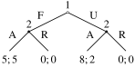
In the game pictured here, there are two players. Player 1 moves first and chooses either F or U. Player 2 sees Player 1's move and then chooses A or R. Suppose that Player 1 chooses U and then Player 2 chooses A, then Player 1 gets 8 and Player 2 gets 2.
The extensive form can also capture simultaneous-move games and games with incomplete information. Either a dotted line or circle is drawn around two different vertices to represent them as being part of the same information set (i.e., the players do not know at which point they are).

Types of games

1. Symmetric and asymmetric
A symmetric game is a game where the payoffs for playing a particular strategy depend only on the other strategies employed, not on who is playing them. If the identities of the players can be changed without changing the payoff to the strategies, then a game is symmetric. Many of the commonly studied 2×2 games are symmetric. The standard representations of prisoner's dilemma, and the stag hunt are all symmetric games.
 | E | F
E | 1, 2 | 0, 0
F | 0, 0 | 1, 2
An asymmetric game

Most commonly studied asymmetric games are games where there are not id entical strategy sets for both players. For instance, the ultimatum game and similarly the dictator game have different strategies for each player. It is possible, however, for a game to have identical strategies for both players, yet be asymmetric. For example, the game pictured to the right is asymmetric despite having identical strategy sets for both players.

2. Zero sum and non-zero sum
Zero sum games are a special case of constant sum games, in which choices by players can neither increase nor decrease the available resources. In zero-sum games the total benefit to all players in the game, for every combination of strategies, always adds to zero (more informally, a player benefits only at the expense of others). Poker exemplifies a zero-sum game (ignoring the possibility of the house's cut), because one wins exactly the amount one's opponents lose. Other zero sum games include classical board games such as go and chess.

 | A | B
A | –1, 1 | 3, –3
B | 0, 0 | –2, 2
A zero-sum game

Many games studied by game theorists are non-zero-sum games, because some outcomes have net results greater or less than zero. Informally, in non-zero-sum games, a gain by one player does not necessarily correspond with a loss by another.
Constant sum games correspond to activities like theft and gambling, but not to the fundamental economic situation in which there are potential gains from trade. It is possible to transform any game into a (possibly asymmetric) zero-sum game by adding an additional dummy player (often called "the board"), whose losses compensate the players' net winnings.

3. Simultaneous and sequential
Simultaneous games are games where both players move simultaneously, or if they do not move simultaneously, the later players are unaware of the earlier players' actions (making them effectively simultaneous). Sequential games (or dynamic games) are games where later players have some knowledge about earlier actions. This need not be perfect knowledge about every action of earlier players; it might be very little information.
For instance, a player may know that an earlier player did not perform one particular action, while he does not know which of the other available actions the first player actually performed. Normal form is used to represent simultaneous games, and extensive form is used to represent sequential ones.

4. Perfect information and imperfect information
A game of imperfect information (the dotted line represents ignorance on the part of player 2) is shown below. An important subset of sequential games consists of games of perfect information. A game is one of perfect information if all players know the moves previously made by all other players. Thus, only sequential games can be games of perfect information, since in simultaneous games not every player knows the actions of the others. Perfect information games include chess, go.

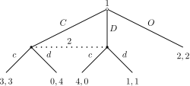

Perfect information is often confused with complete information, which is a similar concept. Complete information requires that every player knows the strategies and payoffs of the other players but not necessarily the actions.

5. Infinitely long games
Games, as studied by economists and real-world game players, are generally finished in a finite number of moves. Pure mathematicians are not so constrained, and set theorists in particular study games that last for infinitely many moves, with the winner (or other payoff) not known until after all those moves are completed.
The focus of attention is usually not so much on what is the best way to play such a game, but simply on whether one or the other player has a winning strategy. (It can be proven, using the axiom of choice, that there are games—even with perfect information, and where the only outcomes are "win" or "lose"—for which neither player has a winning strategy.) The existence of such strategies, for cleverly designed games, has important consequences in descriptive set theory.
Games as search problem
  - Initial state: Initial State is the current board/position
  - Operators: legal moves and their resulting states
  - A terminal test: decide if the game has ended
  - A utility function (Payoff function): produces a numerical value for (only) the terminal states. Example: In chess, outcome = win/loss/draw, with values +1, -1, 0 respectively
Game Trees
The sequence of states formed by possible moves is called a game tree ; each level of the tree is called a ply. In 2 player games we call the two players Max (us) and Min (the opponent).WIN refers to winning for Max. At each ply, the "turn" switches to the other player.
Each level of search nodes in the tree corresponds to all the possible board configurations for a particular player – Max or Min. Utility values found at the end can be returned back to their parent nodes. So, winning for Min is losing for Max. Max wants to end in a board with +1 and Min in a board with a value of -1.
Max chooses the board with the max utility value, Min the minimum. Max is the first player and Min is the second. Every player needs a strategy. For example, the strategy for Max is to reach a winning terminal state regardless of what Min does. Even for simple games, the search tree is huge.
Minimax Algorithm
The Minimax Game Tree is used for programming computers to play games in which there are two players taking turns to play moves. Physically, it is just a tree of all possible moves.
With a full minimax tree, the computer could look ahead for each move to determine the best possible move. Of course, as you can see in example diagram shown below, the tree can get very big with only a few moves. Thus, for large games like Chess and Go, computer programs are forced to estimate who is winning or losing by focusing on just the top portion of the entire tree. In addition, programmers have come up with all sorts of algorithms and tricks such as Alpha-Beta pruning.
The minimax game tree, of course, cannot be used very well for games in which the computer cannot see the possible moves. So, minimax game trees are best used for games in which both players can see the entire game situation. These kinds of games, such as checkers, othello, chess, and go, are called games of perfect information.
For instance, take a look at the following (partial) search tree for Tic-Tac-Toe. Notice that unlike other trees like binary trees, 2-3 trees, and heap trees, a node in the game tree can have any number of children, depending on the game situation. Let us assign points to the outcome of a game of Tic-Tac-Toe. If X wins, the game situation is given the point value of 1. If O wins, the game has a point value of -1. Now, X will be trying to maximize the point value, while O will be trying to minimize the point value. So, one of the first researchers on the minimax tree decided to name player X as Max and player O as Min. Thus, the entire data structure came to be called the minimax game tree.
The games we will consider here are:
- two-person: there are two players.
- perfect information: both players have complete information about the state of the game. (Chess has this property, but poker does not.)
- zero-sum: if we count a win as +1, a tie as 0, and a loss as -1, the sum of scores for both players is always zero.
Examples of such games are chess, checkers, and tic-tac-toe.
This minimax logic can also be extended to games like chess. In these more complicated games, however, the programs can only look at the part of the minimax tree; often, the programs can't even see the end of the game because it is so far down the tree. So, the computer only looks at a certain number of nodes and then stops. Then the computer tries to estimate who is winning and losing in each node, and these estimates result in a numerical point value for that game position. If the computer is playing as Max, the computer will try to maximize the point value of the position, with a win (checkmate) being equal to the largest possible value (positive 1 million, let's say). If the computer is playing as Min, it will obviously try to minimize the point value, with a win being equal to the smallest possible value (negative 1 million, for instance).
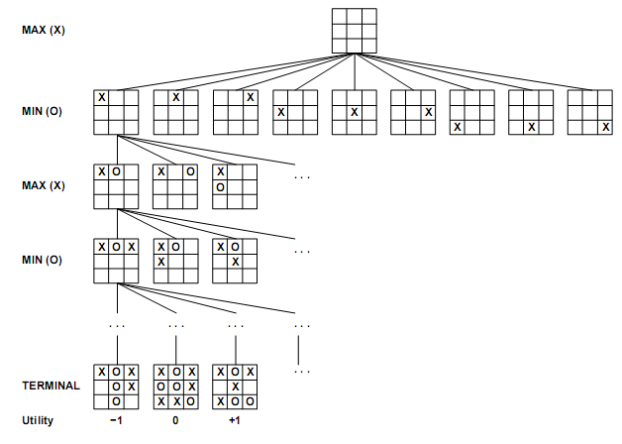
Fig : A (partial)search tree for the game of Tic-Tac-Toe is shown above. The top node is the initial state and max moves first placing an X in an empty square. We show part of the search tree, giving alternating moves by min(O) and max until we eventually reach terminal states, which can be assigned utilities according to the rules of the game.

Minimax Evaluation
The Min-Max algorithm is applied in two player games, such as tic-tac-toe, checkers, chess, go, and so on. All these games have at least one thing in common, they are logic games. This means that they can be described by a set of rules and premises. With them, it is possible to know from a given point in the game, what are the next available moves. So they also share other characteristic, they are ‘full information games’. Each player knows everything about the possible moves of the adversary.
- A search tree is generated, depth-first, starting with the current game position up to the end game position.
- Compute the values (through the utility function) for all the terminal states.
- Afterwards, compute the utility of the nodes one level higher up in the search tree (up from the terminal states. The nodes that belong to the MAX player receive the maximum value of its children. The nodes for the MIN player will select the minimum value of its children.
- Continue backing up the values from the leaf nodes towards the root.
- When the root is reached, Max chooses the move that leads to the highest value (optimal move).
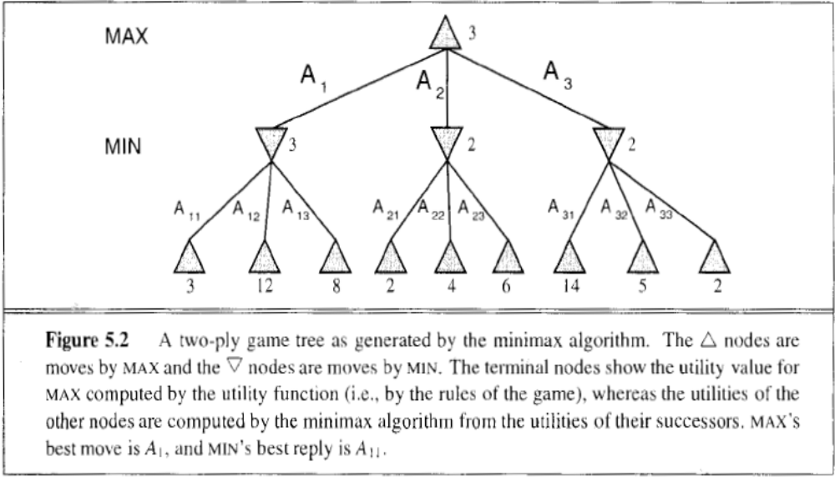
Given a game tree the optimal strategy can be determined by examining the minimax value of each node which we can write as MINIMAX-VALUE (n). Utility value is the value of a terminal node in the game tree. Minimax value of a terminal state is just its utility. Minimax value indicates the best value that the current player can possibly get. It’s either the max or the min of a bunch of utility values. The minimax algorithm is a depth-first search. The space requirements are linear with respect to b and m where b is the no of legal moves at each point and m is the maximum depth of the tree. For real games, the time cost is impractical.
The minimax search will be as below:

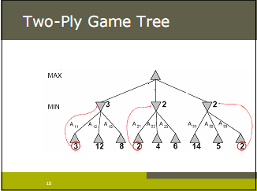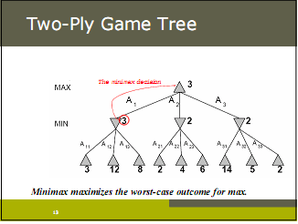

Algorithm:

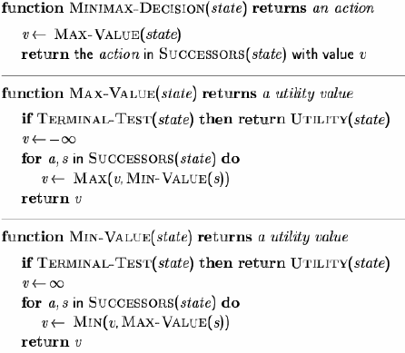

The MINIMAX value of a node can be calculated as

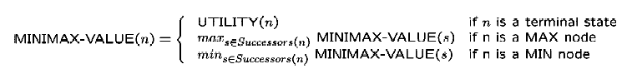

Above shown is an algorithm for calculating minimax decisions. It returns the action corresponding to the best possible move, that is, the move that leads to the outcome with the best utility, under the assumption that the opponent plays to minimize utility. The function MAXVALUE and MINVALUE go through the whole game tree all the way to the leaves to determine the backed up value of a state.

Completeness: Yes (if tree is finite)
Time complexity: O(b^{d}), where d is the depth of the tree.
Space complexity: O(bd) (depth-first exploration), where d is the depth of the tree.
Optimality: Yes, provided perfect info (evaluation function) and opponent is optimal

Alpha-Beta Search

The problem with minimax search is that the no of game states it has to examine is exponential in the no of moves. Minimax helps us look ahead four or five ply in chess. Average human chess players can make plans six or eight ply ahead. But it is possible to compute the correct minimax decision without looking at every node in the game tree. Alpha-beta pruning can be used in this context. It is similar to the minimax algorithm (applied to the same tree) it returns the same move as minimax would but prunes branches that cannot possibly influence the final decision.

- alpha is the value of the best choice (highest value) we have found till now along the path for MAX.
- beta is the value of the best choice (lowest value) we have found so far along the path for MIN.

Alpha-beta pruning changes the values for alpha or beta as it moves and prunes a sub tree as soon as it finds out that it is worse than the current value for alpha or beta. If two nodes in the hierarchy have incompatible inequalities (no possible overlap), then we know that the node below will not be chosen, and we can stop search.

Implementing Alpha-Beta Search
Alpha-beta search is easily implemented by adding &alpha and &beta parameters to a depth-first minimax search. The alpha-beta search simply quits early and returns the current value when &alpha or &beta threshold is exceeded. Alpha-beta search performs best if the best moves (for Max) and worst moves (for Min) are considered first; in this case, the search complexity is reduced to O(b^{d/2}) . For games with high symmetry (e.g. chess), a transposition table (Closed list) containing values for previously evaluated positions can greatly improve efficiency.
Alpha-Beta Search Example
Bounded depth-first search is usually used, with the alpha-beta algorithm, for game trees. However:
- The depth bound may stop search just as things get interesting (e.g. in the middle of a piece exchange in chess. For this reason, the depth bound is usually extended to the end of an exchange.
- The search may tend to postpone bad news until after the depth bound: the horizon effect.
Frequently, large parts of the search space are irrelevant to the final decision and can be pruned. No need to explore options that are already definitely worse than the current best option. Consider again the 2 ply game tree from Fig 5.2. If we go through the calculation of optimal decision once more we can identify the minimax decision without ever evaluating 2 of the leaf nodes.
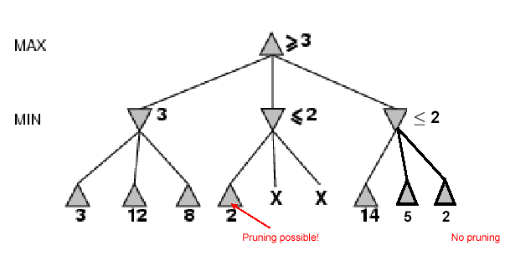
Let the 2 unevaluated nodes be x and y and let z be the minimum of x and y. The value of root node is given by
MINIMAX-VALUE (root) = max(min(3,12,8), min(2,x,y),min(14,5,2))
= max(3,min(2,x,y),2)
= max(3,z,2) where z≤2
= 3.
In other words the value of root and hence the minimax decision are independent of the values of the pruned leaves x and y. Alpha beta pruning can be applied to trees of any depth, and it is often possible to prune entire sub trees rather than just leaves. The general principle is this: consider a node n somewhere in the tree such that a player has a choice of moving to that node. If the player has a better choice m either at the parent node of n or at any choice point further up, then n will never be reached in actual play.
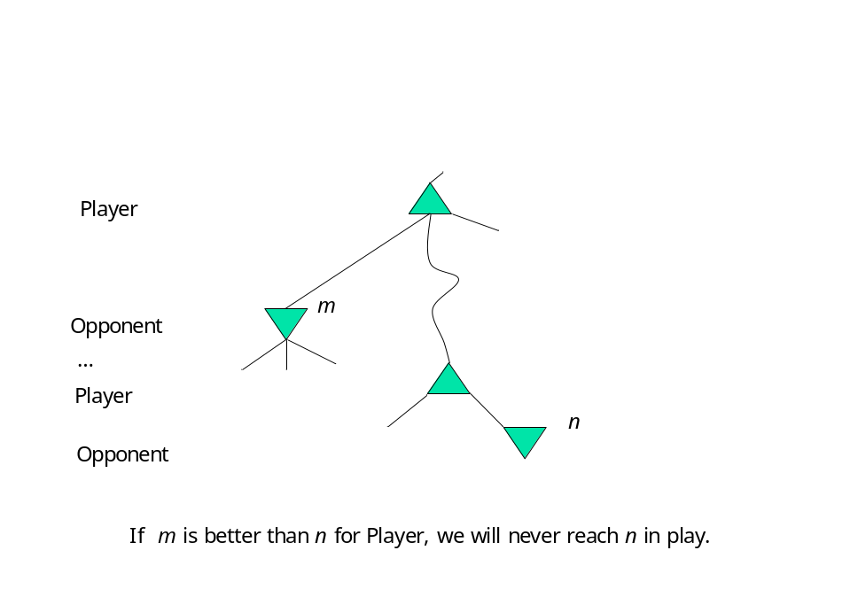
Algorithm:

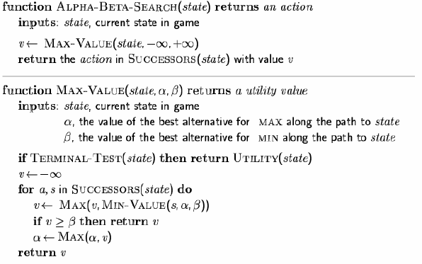
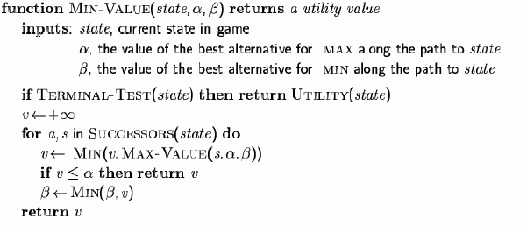
The minimax search is depth first so at any one time we just have to consider the nodes along a single path in the tree. The effectiveness of alpha beta pruning is highly dependent on the order in which the successors are examined. In games repeated states occur frequently because of transpositions- different permutations of the move sequence that end up in the same position. It is worthwhile to store the evaluation of this position in a hash table the first time it is encountered so that we don’t have to recompute it on subsequent occurrences.
The hash table of previously seen positions is traditionally called transposition table. It is essentially identical to the CLOSED list in graph search. If we are evaluating a million nodes per second, it is not practical to keep all of them in the transposition table. Various strategies can be used to choose the most valuable ones.
Limitations of alpha-beta Pruning

- Still dependant on search order. Can apply best-first search techniques
- Still has to search to terminal states for parts of the tree
- Depth may not be practical due to time Constraints

Completeness: Yes, provided the tree is finite
Time complexity: O(b^{d}) in worst case where d is the depth of the tree. In best case Alpha-Beta, i.e., minimax with alpha-beta pruning, runs in time O(b^{d/2}) , thus allowing us to evaluate a game tree twice as deep as we could with plain minimax.
Space complexity: O(bd) (depth-first exploration), where d is the depth of the tree
Optimality: yes, provided perfect info (evaluation function) and opponent is optimal
where d: Depth of tree and b: Legal moves at each point

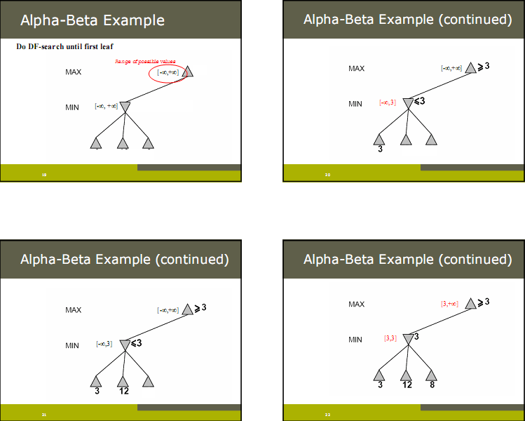

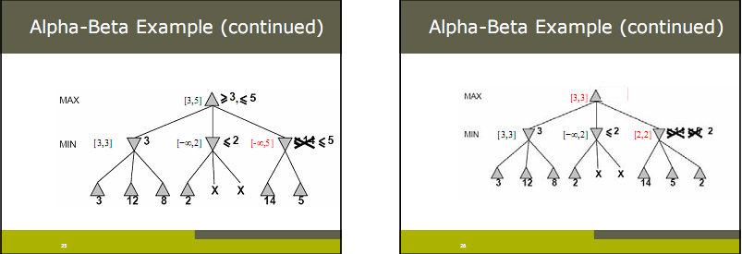

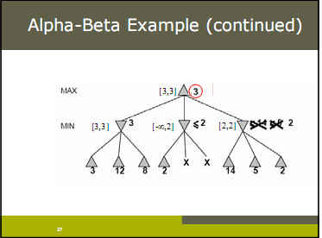

State-Of- The-Art-Game Programs

Introduction

We give some details of recent programs in variety of different types of games for playing two-person games. For some time there have been good programs for playing Backgammon, Othello and Draughts and in fact now there exist programs which are world champion status in all three areas. TD-Gammon has revolutionized the classic game of backgammon. TD-Gammon actually taught itself to play backgammon, starting from scratch, by using breakthrough research in Artificial Neural Networks. TD-Gammon learned to play well enough to rank among the best players in the world. Also Connect–4 and go–moku can be played perfectly by programs. We begin with Chess, where it has taken quite a while to produce a world–class program.

- Chess
Deep Blue the chess program from IBM beat the world champion Kasparov 3.5 – 2.5 in May 1997. It has special purpose hardware and can evaluate 200 million moves per second. The special purpose hardware clearly helped, but carefully tuned software is also essential.

If we take a typical length game of chess, then there are 10125 possible nodes in the full game tree. This would take more than 10108 years to search if 109 moves could be investigated per second.

Deep Blue, uses search using mainly what is called singular extensions. It does say a 10 ply search, and then identifies the interesting lines of play to extend the search to a deeper level (say 30 – 40 ply).

It also has other types of extensions. Threat extension is used if a position of threat is discovered. Influence extension if for example there is a free pawn which can move to become a queen.

The software is used to perform the initial search and then the special purpose hardware for the last 5 ply. The evaluation heuristic function makes use of a great deal of information such as:
• how good a position is it e.g. difference in number of pieces;
• position of important pieces (e.g. bishop on black is no good if all opponents pieces on white);

Deep Blue is compared with grand masters games to tune the evaluation function. Also did some manual tuning by playing against a grand master until poor move identified. Much of the tree is evaluated in parallel using the 512 special purpose chips with minimal communication. IBM are interested in exploiting what has been learnt from Deep Blue in real world problems. These include such areas as:

• financial risk (using Monte Carlo simulations);
• data mining;
• molecular dynamics simulation – of interest in pharmaceutical modelling (hope to deal with 100,000 atoms.
• use the visualisation tools developed for use in other domains

More recently, a program called X3D Fritz has come on the Chess scene and is a competitor to Deep Blue. X3D Fritz has played four games against Kasparov in November 2003. The scores were 1 win for Kasparov, 1 win for X3D Fritz and two draws. The game is played on a computer with a 3D chess board when viewed through special glasses. Kasparov received $175K for the games.

- Checkers

The game of Checkers or Draughts is played on a board of sixty-four squares of alternate colors, usually referred as black and white although not necessarily of those colors. Twenty-four pieces (fat round counters), called men (twelve on each side) also of opposite colors are located on the game board. The game is played by two persons; the one having the twelve black or red pieces is technically said to be playing the tint side, and the other having the twelve white "men", to be playing the second side.
Samuels learning program eventually beat developer. Chinook is world champion, previous champ held title for 40 years had to withdraw for health reasons. It has all end games from 8 pieces pre–computed. This is 440×109 positions and is compressed to 6 gigabytes. It uses 25 play look-ahead tree, and so in the tree soon comes to end positions. Chinook drew with the world champion Tinsley in 1994. He was considered the best champion there has ever been in draughts.

The techniques developed are being used in BioTools which is a program for DNA synthesis. David Fogel has used evolutionary programming to automatically generate a draughts playing program called Blondie24. This was played against human players on the web and eventually obtained a rating of 2,000. The evolutionary program generated a neural network which was used to evaluate a heuristic function for mini-max.

The object of the game is to capture all of the opponent's men, or block them so they cannot be moved, the person whose side is brought to this state loses the game.

- Othello

Reversi and Othello are names for a strategic board game which involves play by two parties on an eight-by-eight square grid with pieces that have two distinct sides. Pieces typically appear coin-like, but with a light and a dark face, each side representing one player. The object of the game is to make your pieces constitute a majority of the pieces on the board at the end of the game, by turning over as many of your opponent's pieces as you can.

Othello also called Reversi is probably more popular as a computer game than as a board game. It has a smaller search space than chess, usually 5 to 15 legal moves, but evaluation expertise had to be developed from scratch. In 1997 the Logistello program defeated the human world champion Takesh Murakami by 6 games to none. It is generally acknowledged that humans are no match for computers at Othello.

- Backgammon

Most work on blackgammon has gone into improving the evaluation function. Gerry Tesauro combined Samuel’s reinforcement learning method with neural network techniques to develop a remarkably accurate evaluator that is used with a search to depth 2 or 3. After playing more than a million training games against itself, Tesauro’s program, TD Gammon is reliably ranked among the top 3 players in the world.

- Go

Go is a strategic board game for two players. It is also known as Weiqi in Chinese, Igo or Go in Japanese. Go originated in ancient China, centuries before it was first mentioned in writing 548 BC. It is now popular throughout the world, especially in East Asia.

Go is played by two players alternately placing black and white stones on the vacant intersections of a 19×19 line grid. A stone or a group of stones is captured and removed if it is tightly surrounded by stones of the opposing color. The objective is to control a larger territory than the opponent's by placing one's stones so they cannot be captured. The game ends and the score is counted when both players consecutively pass on a turn, indicating that neither side can increase its territory or reduce its opponent's.

In game theory terms, Go is a zero-sum, perfect information, deterministic strategy game, putting it in the same class as chess, checkers (draughts), and reversi (othello), although it is not similar in its play to these. Although the game rules are very simple, the practical strategy is extremely complex.

The game emphasizes the importance of balance on multiple levels, and has internal tensions. To secure an area of the board, it is good to play moves close together; but to cover the largest area one needs to spread out, perhaps leaving weaknesses that can be exploited. Playing too low (close to the edge) secures insufficient territory and influence; yet playing too high (far from the edge) allows the opponent to invade. Many people find Go attractive for its reflection of the conflicting demands of real life.

- Bridge

Contract bridge, usually known simply as bridge, is a trick-taking card game of skill and chance (the relative proportions depend on the variant played). It is played by four players who form two partnerships (sides); the partners sit opposite each other at a table. The game consists of the auction (often called bidding) and play, after which the hand is scored.

The bidding ends with a contract, which is a declaration by one partnership that their side shall take at least a stated number of tricks, with specified suit as trump or without trumps. The rules of play are similar to other trick-taking games with the addition of the fact that one player's hand is displayed face up on the table as the "dummy".

Much of bridge's popularity owes to the possibility that it can be played in tournaments of theoretically unlimited number of players; this form is referred to as duplicate bridge.

Knowledge Representation

It is a medium for human expression. An intelligent system must have Knowledge Representations that can be interpreted by humans. We need to be able to encode information in the knowledge base without significant effort. We need to be able to understand what the system knows and how it draws its conclusions.
It is necessary to represent the computer's knowledge of the world by some kind of data structures in the machine's memory. Traditional computer programs deal with large amounts of data that are structured in simple and uniform ways. A.I. programs need to deal with complex relationships, reflecting the complexity of the real world.
Several kinds of knowledge need to be represented:
- Factual Data: Known facts about the world.
- General Principles: ``Every dog is a mammal.''
- Hypothetical Data: The computer must consider hypotheticals in order to reason about the effects of actions that are being contemplated.

Types

- Logic (prepositional, predicate)
- Network representation
  - Semantic nets
- Structured representation
  - Frames

Semantic Nets
Semantic Nets were invented by Quillian in 1969. Quillian was a Psychologist (at UMich) and was trying to define the structure of human knowledge. Semantic Nets are about relations between concepts. Semantic Nets use a graph structure so that concepts are nodes in the graph.
An important feature of human memory is the high number of connections or associations between the different pieces of information contained in it. A semantic network is one of the knowledge representation languages based on this intuition. The basic idea of a semantic network representation is very simple: There are two types of primitive, nodes and links or arcs. Links are unidirectional connections between nodes. Nodes correspond to objects, or classes of objects, in the world, whereas links correspond to relationships between these objects.
Semantic nets are usually used to represent static, taxonomic, concept dictionaries. Semantic nets were originally designed as a way to represent the meanings of English words. In a semantic net, information is represented as a set of nodes connected to each other by a set of labeled arcs, which represent relationships among the nodes. Major problem with semantic nets is that although the name of this knowledge representation language is semantic nets, there is not, ironically, clear semantics of the various network representations. A fragment of a typical semantic net is shown in Figure 1 below.
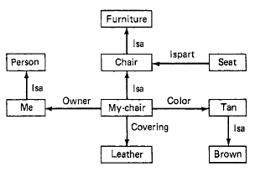
Figure 1: A Semantic Network
It is useful to think about semantic nets using a graphical notation, as shown in the figure. Of course, they cannot be represented inside a program that way. Instead, they are usually represented using some kind of attribute-value memory structure.
Notice that each property stores a one-way link, such as the arc from MY-CHAIR to ME. To store bidirectional links, it is necessary to store each half separately. So if we wanted to be able to answer the question "What do I own?" without searching the entire net, we would need arcs from ME to all the nodes that connect to ME via OWNER arcs. Since it means something different to go from MY-CHAIR to ME than it does to go from ME to MY-CHAIR, we need a new kind of arc, which we can call OWNED. It is, of course, more efficient to store only one-way arcs. But then it is difficult to form inferences that go in the missing direction.
For each system, it is necessary to decide what kind of inferences will be needed and then to design the links appropriately; this is the same problem that designers of any database must solve when they decide what fields to index on.
Important semantic relations:
• Meronymy (A is part of B, i.e. B has A as a part of itself)
• Holonymy (B is part of A, i.e. A has B as a part of itself)
• Hyponymy (or troponymy) (A is subordinate of B; A is kind of B)
• Hypernymy (A is superordinate of B)
• Synonymy (A denotes the same as B)
• Antonymy (A denotes the opposite of B)
Representing Non-binary Predicates
Semantic nets can be used to represent relationships that would appear as two-place predicates in predicate logic. For example, some of the arcs from Figure 1 could be represented in logic as
ISA(chair, furniture)
ISA(me,person)
COVERING(my-chair,leather)
COLOR(my-chair ,tan)
We have already seen that many one-place predicates in logic can be thought of as two-place predicates using some very general-purpose predicates, such as ISA. But the knowledge expressed by other predicates can also be expressed in semantic nets. So, for example,
MAN(Marcus)
could be rewritten as
ISA(Marcus, man)
thereby making it easy to represent in a semantic net.
Three or more place predicates can also be converted to a binary form by creating one new object representing the entire predicate statement and then introducing binary predicates to describe the relationship to this new object of each of the original arguments. For example, suppose we know that
SCORE(red blue (17 3))
This can be represented in a semantic net by creating a node to represent the specific game and then relating each of the three pieces of information to it. Doing this produces the network shown in Figure 2.
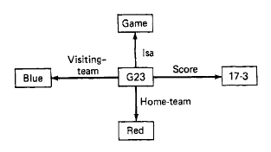
Figure 2: A Semantic Net for an N-Place Predicate
This technique is particularly useful for representing the contents of a typical declarative sentence, which describes several aspects of a particular event. The sentence
John gave the book to Mary
could be represented by the network shown in Figure 3.
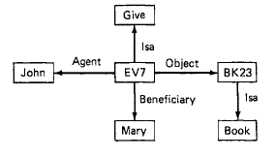
Figure 3: A Semantic Net Representing a Sentence
The node labeled BK23 represents the particular book that was referred to by the phrase the book. Note that we are again using a case grammar analysis of the sentence. Semantic nets have been used to represent a variety of kinds of knowledge in a variety of different programs.
Reasoning with the Knowledge
As with any other mechanism for representing knowledge, the power of semantic nets lies in the ability of programs to manipulate them to solve problems. One of the early ways that semantic nets were used was to find relationships among objects by spreading activation out from each of two nodes and seeing where the activation met. This process was called intersection search. Using this process, it is possible to use the network of figure below to answer questions such as
Question: “What is the relation between Chicago cubs and Brooklyn Dodgers?”
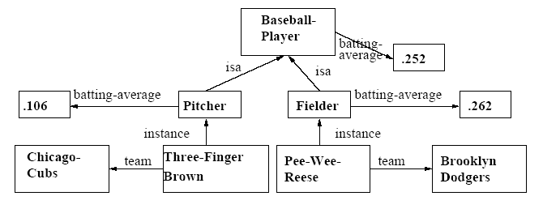
Answer: “They are both teams of baseball players.”
More recent applications of semantic nets have used more directed search procedures to answer specific questions. Although in principle there are no restrictions on the way information can be represented in the networks, these search procedures can only be effective if there is consistency in what each node and each link mean. Let's look at a couple of examples of this.
There is a difference between a concept (such as GAME or GIVE) and instances of that concept (such as G23 or EV7). Whereas my chair can get wet, the concept chair cannot. If information about specific instances is stored at the node representing the concept, it is not possible to differentiate among multiple instances of the same concept. For example, we could represent the fact that
My chair is tan.
using the semantic net as
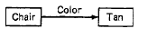
But we would then have a hard time representing the additional fact that Mary's chair is green. To avoid this problem, links from the concept node should usually be used to describe properties of all (or most) instances of the concept, while links from an instance node describe properties of the individual instance. It is important to make explicit this difference between a node representing a class of objects and a node representing an instance of a class.
We have been using ISA links to represent hierarchical relationships between concept nodes, and sometimes also to relate nodes representing specific objects to their associated concepts. But in order to maintain the distinction between concept nodes and instance nodes, we need to introduce a new kind of link by which instance nodes can be connected to the concepts that describe them. We will call this new link INSTANCE-OF. An example of it occurs in the following fragment of a network:
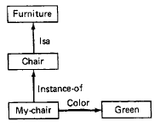
Sometimes it is also important to distinguish between a node representing the canonical instance of a concept and a node representing the set of all instances of it. For example, the set of all Americans is of size two and a quarter million, while the typical American is of size five and a half feet. There is a difference between a link that defines a new entity and one that relates two existing entities. For example
John is 6 ft tall
can be represented using semantic net as below
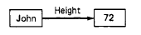
Both nodes represent objects that exist independently of their relationship to each other. But now suppose we want to represent the fact that John is taller than Bill, using the net
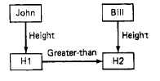
The nodes HI and H2 represent the new concepts JOHN'S-HEIGHT and BILL'S-HEIGHT, respectively. They are defined by their relationships to the nodes JOHN and BILL. Using these defined concepts, it is possible to represent such facts as that John's height increased, which we could not do before. (The number 72 increased?). Sometimes it is useful to introduce the arc VALUE to make this distinction clear. Thus we might represent the fact that John is 6 feet tall and that he is taller than Bill by the net
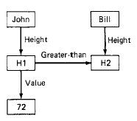
The procedures that operate on nets such as this can exploit the fact that some arcs, such as HEIGHT, define new entities, while others, such as GREATER-THAN and VALUE, merely describe relationships among existing entities.
Partitioned Semantic Nets
One of the major problems with the use of semantic nets to represent knowledge is how to handle quantification. One way of solving the problem is to partition the semantic net into a hierarchical set of spaces, each of which corresponds to the scope of one or more variables. To see how this works, consider first the simple net shown in Figure 4(a). This net corresponds to the statement
The dog bit the postman.
The nodes DOGS, BITE, and POSTMEN represent the classes of dogs, biting, and postmen, respectively, while the nodes D, B, and P represent a particular dog, a particular biting, and a particular postman. This fact can easily be represented by a single net with no partitioning.
But now suppose that we want to represent the fact that
Every dog has bitten a postman.
or, in logic x dog(x)→( y postman(y) bite(x,y))
To represent this fact, it is necessary to encode the scope of the universally quantified variable x. This can be done using partitioning as shown in Figure 4(b). The node g stands for the assertion given above. Node g is an instance of the special class GS of general statements about the world (i.e., those with universal quantifiers). Every element of GS has at least two attributes" a FORM, which states the relation that is being asserted, and one or more V connections, one for each of the universally quantified variables.
In this example, there is only one such variable d, which can stand for any element of the class DOGS. The other two variables in the form, b and p, are understood to be existentially quantified. In other words, for every dog d, there exists a biting event b, and a postman p, such that d is the assailant of b and p is the victim.
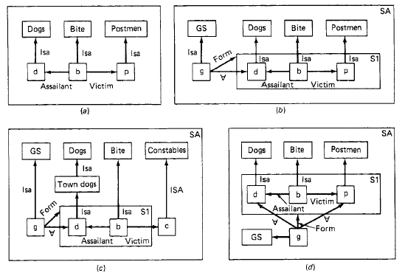
Figure 4: Using Partitioned Semantic Nets
To see how partitioning makes variable quantification explicit, consider next similar sentence:
Every dog in town has bitten the constable.
The representation of this sentence is shown in Figure 7-7(c). In this net, the node c representing the victim lies outside the form of the general statement. Thus it is not viewed as an existentially quantified variable whose value may depend on the value of d. Instead it is interpreted as standing for a specific entity (in this case, a particular constable), just as do other nodes in a standard, non partitioned net.
Figure 4(d) shows how yet another similar sentence:
Every dog has bitten every postman.
In this case, g has two V links, one pointing to d, which represents any dog, and one pointing to p, representing any postman. The spaces of a partitioned semantic net are related to each other by an inclusion hierarchy. For example, in Figure 4(d), space S1 is included in space SA. Whenever a search process operates in a partitioned semantic net, it can explore nodes and arcs in the space from which it starts and in other spaces that contain the starting point, but it cannot go downward, except in special circumstances, such as when a FORM arc is being traversed.
So, returning to Figure 4(d), from node d it can be determined that d must be a dog. But if we were to start at the node DOGS and search for all known instances of dogs traversing ISA links, we would not find d, since it and the link to it are in the space S1, which is at a lower level than space SA, which contains DOGS. This is important, since d does not stand for a particular dog; it is merely a variable that can be instantiated with a value that represents a dog. Partitioned semantic nets have a variety of other uses besides their ability to encode quantification. Semantic nets have been widely used to represent a variety of kinds of knowledge.

Advantages of Semantic nets

Easy to visualize

Formal definitions of semantic networks have been developed.

Related knowledge is easily clustered.

Efficient in space requirements

Objects represented only once

Relationships handled by pointers
Semantic nets have two significant advantages over unstructured sets of logic clauses:

• Economy: each property only needs to be represented once: friendly to people for cat, and so on down to long tail for Maine Coon and orange for Charles Douglas. Imagine what your system would look like if, for every single individual Maine Coon cat, you had to write out all the information about Maine Coons, pedigree cats, cats, ... and so on up to animals (and beyond).

• Significant generalization: in a large system like that, it might not be easy to see that all the Maine Coons had long tails, and even if you did see it, you might think it was a coincidence. By making long tail a property of the class Maine Coon, you make clear both the fact, and that it is significant.

Disadvantages of Semantic nets

Inheritance (particularly from multiple sources and when exceptions in inheritance are wanted) can cause problems.

Facts placed inappropriately cause problems.

No standards about node and arc values

Uses of Semantic Nets

Coding static world knowledge

Built-in fast inference method (inheritance)

